CORELDRAW SYLLABUS (BASIC TO ADVANCED)( 2 – MONTHS)
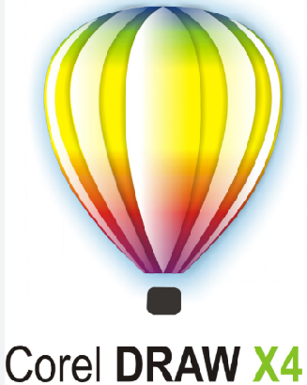
Module 1: Introduction to CorelDRAW
- What is CorelDRAW?
- Interface and Workspace overview
- Tools and toolbars
- Creating, opening, and saving documents
- Page layout and setup
Module 2: Basic Drawing Tools
- Pick Tool, Shape Tool, Crop Tool, Zoom Tool
- Freehand, Bezier, Pen, Polyline tools
- Rectangle, Ellipse, Polygon, and Star tools
- Drawing with precision
Module 3: Working with Shapes and Objects
- Selecting, resizing, rotating, skewing
- Grouping and ungrouping objects

- Aligning and distributing objects
- Using Object Manager
- Shaping tools: Weld, Trim, Intersect, Combine
Module 4: Colors and Fills
- Fill types: Uniform, Fountain, Pattern, Texture
- Outline tool and color palettes
- Eyedropper and Paint Bucket tools
- Color models: RGB, CMYK
- Shortcut Keys
- Question Answer/ Fill in The Blanks

Module 5: Text and Typography
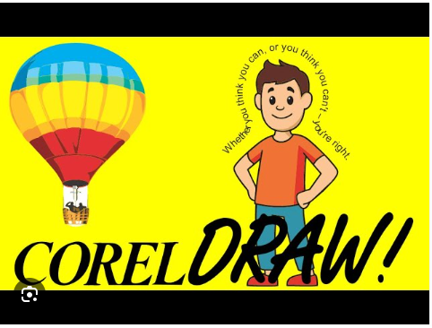
- Artistic vs Paragraph text
- Font selection and text formatting
- Text effects (warp, fit to path, etc.)
- Text alignment and spacing
- Linking text to shapes
Module 6: Working with Bitmaps
- Importing and editing images
- Bitmap tracing (convert image to vector)
- Applying effects to images
- Cropping and power clipping
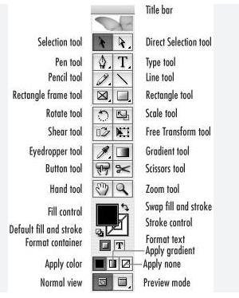
Module 7: Advanced Features
- Layers and Object Manager
- Symbols and clipart
- Custom shapes and templates
- Envelope tool, Blend, Contour, Drop Shadow
- Interactive Fill and Transparency
Module 8: Page Layout and Design Projects
- Creating brochures, logos, visiting cards, banners, posters
- Multi-page document handling
- Exporting to PDF, JPG, PNG, CDR
- Preparing files for print
Module 9: Practical Projects
- Logo Design
- Banner/Flyer Design
- Visiting Card
- Advertisement Layout
- Social Media Post Templates

